PROJECT MOVIE STORE

**Posa Supraja**

[**posasupraja502@gmail.com**](mailto:posasupraja502@gmail.com)

1. Identify the entities and attributes for this problem statement.
   * Customer – Customer ID, Customer Name, Contact, Address, DOB, Age.
   * Purchase- Purchase ID, Purchase Type, Date of Purchase, Expected Return Date, Actual Return Date, Extra No of Days, Total Penalty.
   * Movie- Movie ID, Title, Release Date, IMDB Rating, Runtime, Director, Price.
   * Genre- Genre ID, Genre Name.
   * Role- Role ID, Role Name, Role Info.
   * Actor- Actor ID, Actor Name, DOB, Gender, Age, No of Movies.
2. Identify if there are any composite/ multivalued/ derived attributes.
   * Composite- Customer Name( First Name, Last Name) , Actor Name ( First Name, Last Name).

Note- Address( Street no, Locality, City) could also be Composite but for simplicity i did not considered that.

* + Derived- Customer Age( from Customer DOB), Extra No of Days( from Expected and Actual Return Date) ,Total Penalty( from Extra no of Days), Actor Age( from Actor DOB).
  + Multivalued- Contact of Customer and Director of Movie( There could be more than one director of one movie).

1. Identify what should be the primary key and foreign keys for the entities.
   * Customer- Customer ID (Primary Key)
   * Purchase- Purchase ID ( Primary Key), Movie ID(Foreign Key), Customer ID( Foreign Key).
   * Movie- Movie ID ( Primary Key), Genre ID( Foreign Key).
   * Genre- Genre ID ( Primary Key)
   * Role- Role ID ( Primary Key), Movie ID ( Foreign Key), Actor ID ( Foreign Key).
   * Actor- Actor ID( Primary Key).
2. Identify the relationship name which should exist among the entities. Also, mention the cardinality ratio (1:1. 1:N, M:N) for eachrelationship.
   * Customer Made Purchase -- 1:N ( one to many)
   * Purchase Buy/Rent Movie -- M:N (many to many)
   * Movie has Genre -- M:N (many to many)
   * Movie has Role -- 1:N ( one to many)
   * Actor Played Role – 1:N (one to many)
3. Now, combining all the information you derived from the above, draw the complete ER Diagram

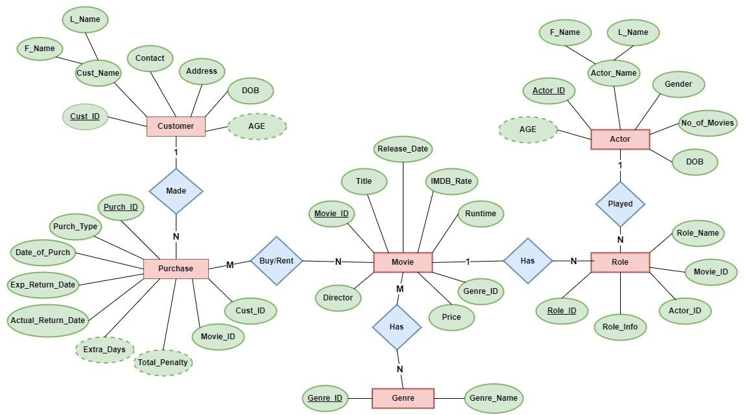

1. Create the Relational Schema for the above ER-diagram.

